Empowering The Future : A

# Literacy Rate Analysis For A Better Future Tomorrow

❑Here we are analysing the literacy rate in India for 2021.

❑This dataset contains a record Literacy Rate each states of India, here we are going to analyse State wise,Region wise and Overall Literacy rate among



Children, Women and men in India in India

The file India_Updated Literacy 2021.csv contains

112 rows. Each row corresponds to record of state with details and marks in respective subjects. The columns are: Columns are:

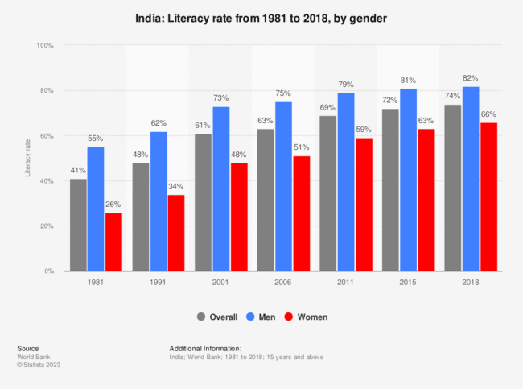•States- Indian States

•Area- Rural or Urban Area •Children age 5 years who attended pre-primary school •Women (age 15-49) (%)

•Men (age 15-49) (%)

•Women (age 15-49) with 10 or more years of schooling (%) •Men (age 15-49) with 10 or more years of schooling (%)

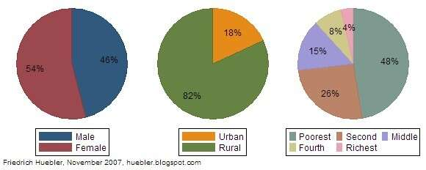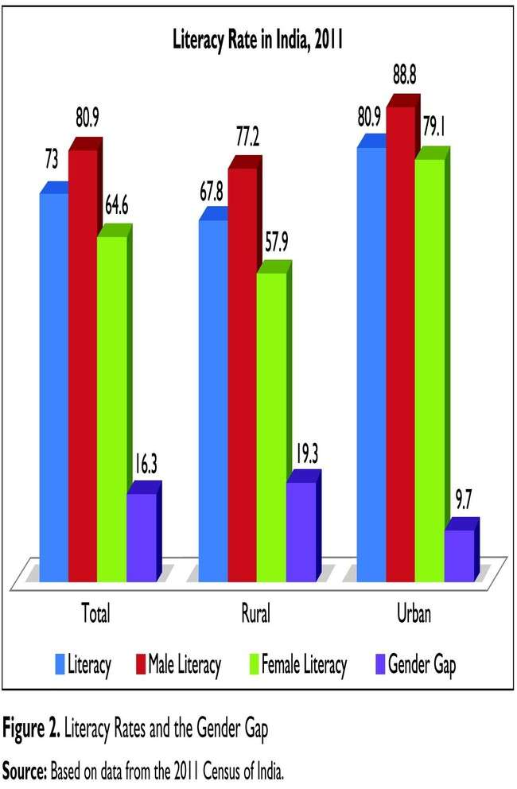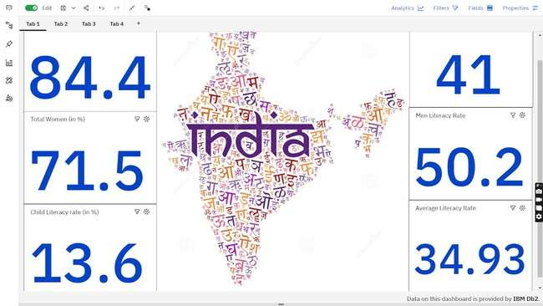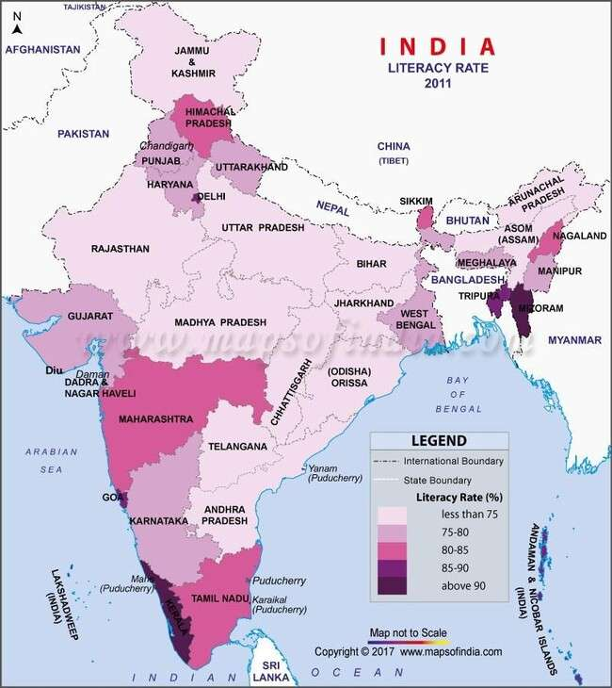

|  |  |
| --- | --- |
| India Literacy Rate (According to 2011 Census) | |
| Overall | 74.04% |
| Male | 82.14% |
| Female | 65.46% |

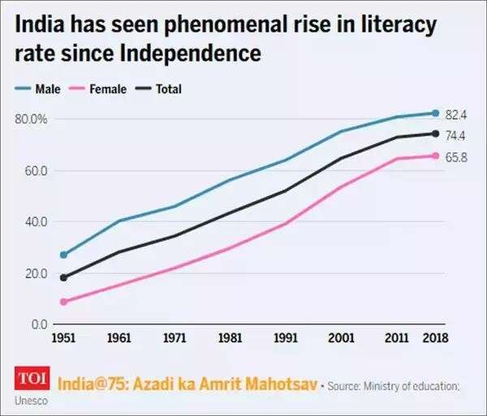Literacy plays a major role in the economic development of a nation. Although India has raised its current literacy rate of 74.04% (2021) from 12% at the time of Independence in 1947, its still lag behind the world average literacy rate of 84%. Compared with other nations, Republic of India has the largest illiterate population.

Majority of states in India has shown majors signs of improvement in their overall illiteracy rate thus contributing towards a literate nation Here we are analysing literacy rate in India for 2021. This dataset contains a record Literacy rate each states of India, here we are going to analyse State wise, Region wise and Overall Literacy rate among Children, Women and Men in India in India.

